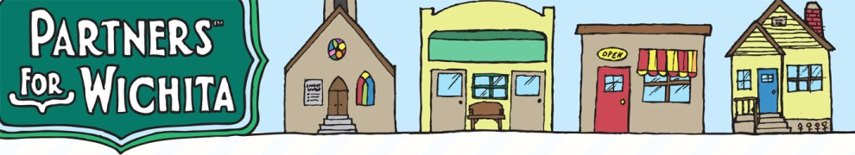
TRIVIA NIGHT FUNDRAISER
Partners for Wichita is hosting their popular Trivia Night Fundraiser on Saturday, February 16, 2019. This event will be held at First Presbyterian Church, 525 N. Broadway. Doors will open at 6:15pm and trivia will begin at 7:00pm. The cost is $120 for teams of eight people registered in advance (a savings). Otherwise, the cost is $20 per individual, in advance or at the door. The price of admission includes a fun-filled night of trivia and games, soda, water, and snacks. Please feel free to bring your own snacks, but please, no alcohol.

What is a TRIVIA NIGHT? Teams of 8 people compete against other teams through 10 rounds of trivia. Each round will have 10 questions and the team works together to answer the questions. At the end of the night, the team with the most correct answers wins a prize. There is time between rounds to enjoy conversation, laughter, and bid on the silent auction items. Trivia categories can vary greatly. Throughout the evening, we’ll play other fun games like 50/50 raffle and Heads or Tails, give attendance prizes, etc., trying to raise as much money as possible to support Partners for Wichita.

What is PARTNERS FOR WICHITA? The mission of Partners for Wichita is to pursue peace and well-being in Wichita and beyond through partnerships, by connecting individuals, faith communities, and community organizations to meet urgent needs in the greater Wichita area. Partners for Wichita is especially known for “Filling the Gap Lunches for Kids,” providing nourishing lunches for 800 children each day during critical times of spring break and the end of summer vacation. We gather over 1,600 “Bags of Blessings” filled with essential personal care items from about 50 congregations and distributed through over 30 helping agencies to our neediest neighbors. Our Safe Streets coalition is working for the prevention of drug and alcohol abuse and the reduction of violence in our community. Safe Streets and Youth Corps teach students to value healthy living and community service.

Thank you in advance for your support of Partners for Wichita.
--------------------------------------------------------------------------------------------------------------------------------------
You may pay online at partnersforwichita.org, “Donate” and select “Trivia Night,”
then register your team members via email at info@partnersforwichita.org.
OR, fill out this portion and send with your check, payable to Partners for Wichita, designated Trivia Night, to:
Partners for Wichita, 925 N. Waco, Wichita, KS 67203
Seating is limited so sign up early!
For full teams of 8, $120/table, registered in advance - by Feb. 11, 2019.
Cost per individual (without a team) $20/person. Cost after Feb. 11, or at the door, $20/person.

Team Captain Name: ___________________________________________ Phone Number: ____________________
Address & zip________________________________________________________Email:_________________________
Please list names, address, phone, and email below and on back.
Name: ________________________________________________________ Phone Number: _____________________
Address & Zip________________________________________________________Email: _______________________

Name: ________________________________________________________ Phone Number: _____________________
Address & Zip________________________________________________________Email: _______________________

Name: ________________________________________________________ Phone Number: _____________________
Address & Zip________________________________________________________Email: _______________________

Name: ________________________________________________________ Phone Number: _____________________
Address & Zip________________________________________________________Email: _______________________

Name: ________________________________________________________ Phone Number: _____________________
Address & Zip________________________________________________________Email: _______________________

Name: ________________________________________________________ Phone Number: _____________________
Address & Zip________________________________________________________Email: _______________________

Name: ________________________________________________________ Phone Number: _____________________
Address & Zip________________________________________________________Email: _______________________

